The Classic Labyrinth

Source: https://ellisnelson.com/2013/01/24/walking-the-labyrinth/

Seed Pattern for a 7 Circuit Classic Labyrinth

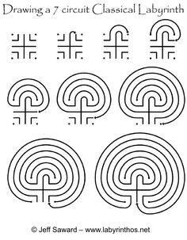

Source: Jeff Saward, www.labyrinthos.net

How to Walk a Labyrinth
- there are no set rules
- walk with an open heart and mind
- take a few deep breaths before setting out
- walk at a natural pace, find your own rhythm
- experience the experience
Three stages:
LET GO (walking in),
LET IN (usually at the centre),
INTEGRATE (walking out, reconnecting)

Guidelines for Walking a Labyrinth
- remove shoes (optional)
- walk with “soft” eyes
- it’s a two-way path, move around people thoughtfully
- stay in the centre as long as you like
- lightly notice feelings and sensations as you walk
- wait respectfully for all to complete their walk before speaking

“You don’t walk the labyrinth to find out about it, you walk the labyrinth to find out about yourself and your relationships.” ~ Eve Hogan

